**APPLICATION DEPLOYMENT**

**Github-Url:** [**https://github.com/ragull-11/devops-build**](https://github.com/ragull-11/devops-build) **React-App:** [**http://18.234.205.243/**](http://18.234.205.243/)

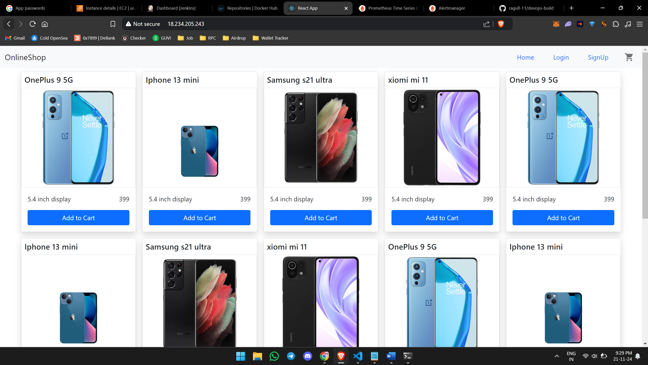

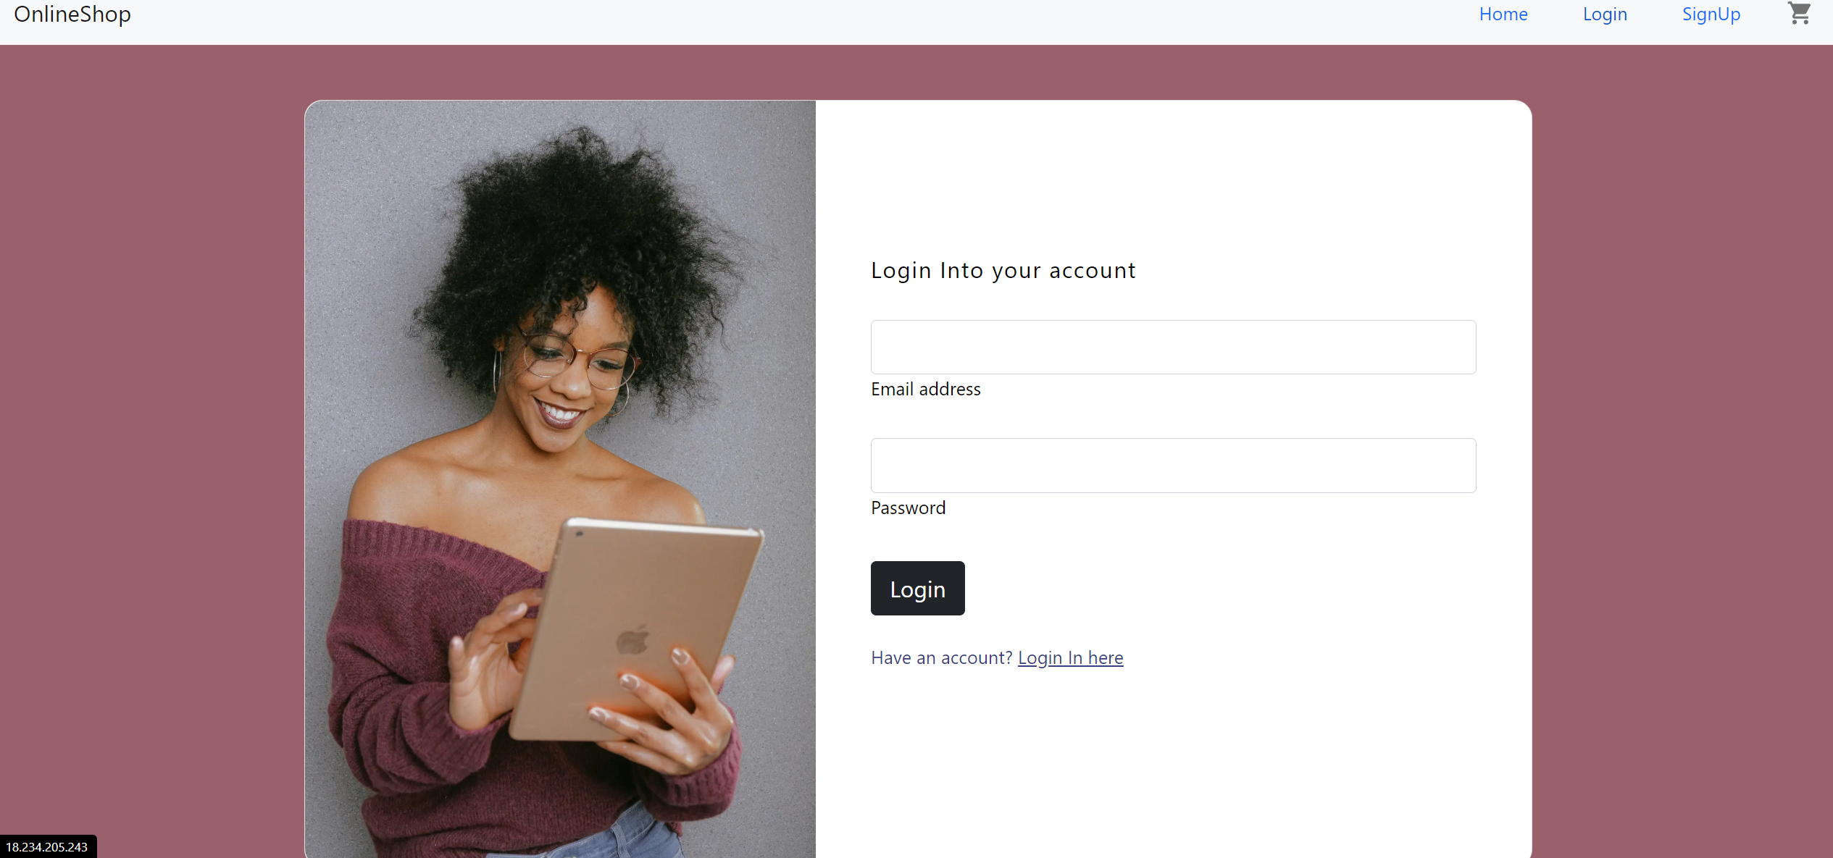

**Docker Images:  
  
Docker hub:** [**https://hub.docker.com/repositories/ragul11**](https://hub.docker.com/repositories/ragul11)

**Dev Repo - ragul11/dev:latest**

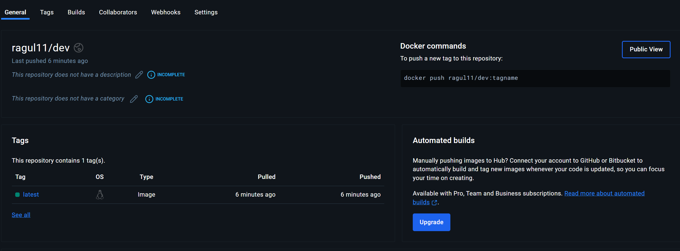

**Prod Repo - ragul11/prod:latest**

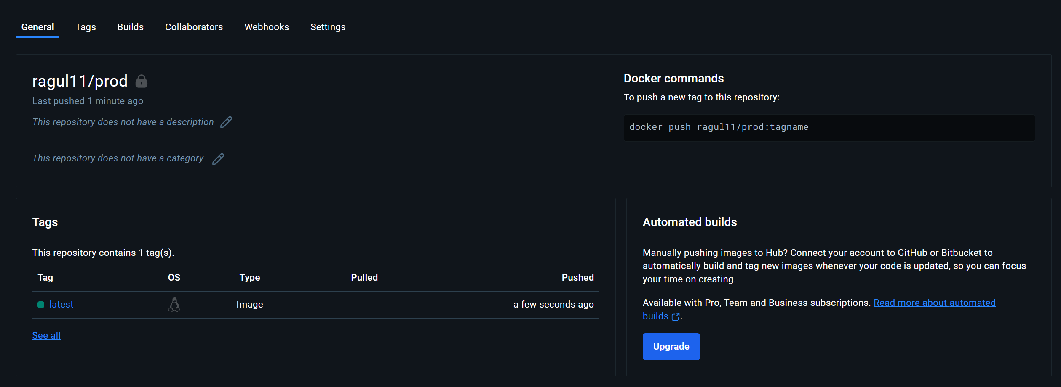

**Jenkins**

**Login Page:**

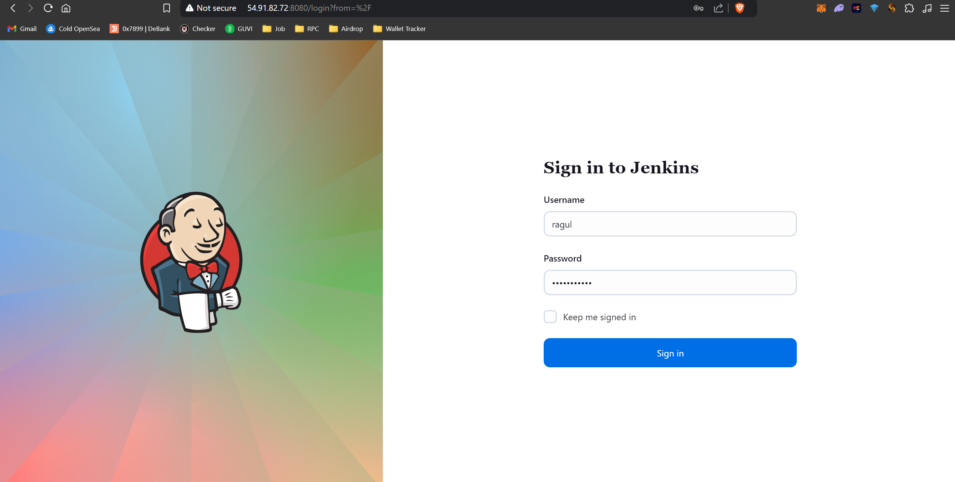

**Credentials:**

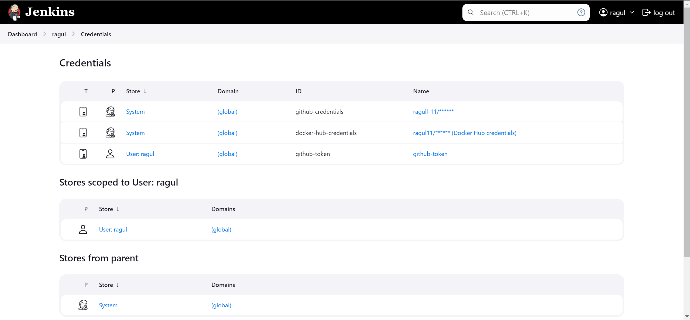

**Configuration settings:**

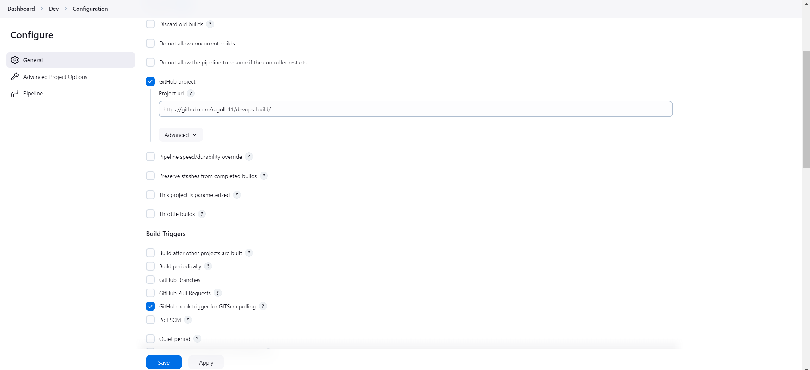

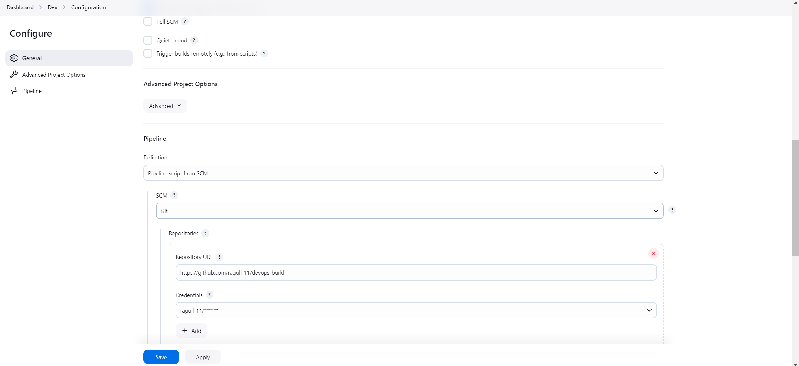

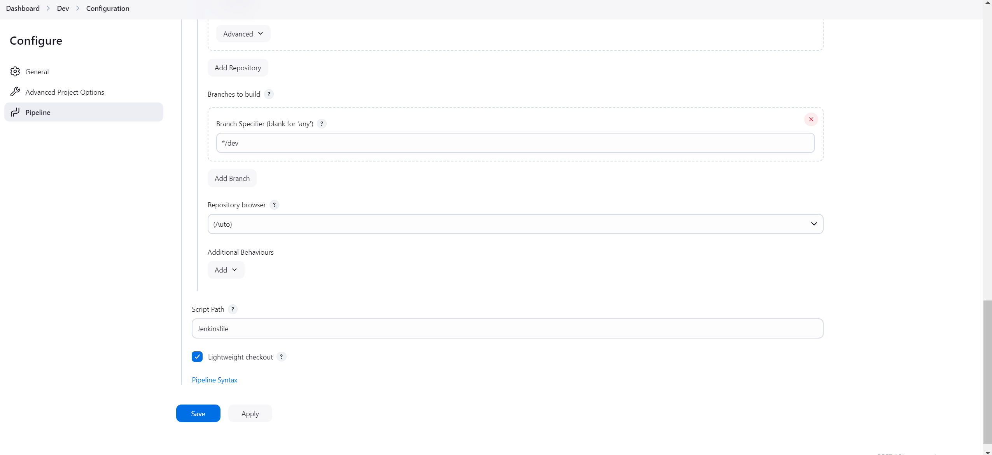

**Console Output:**

**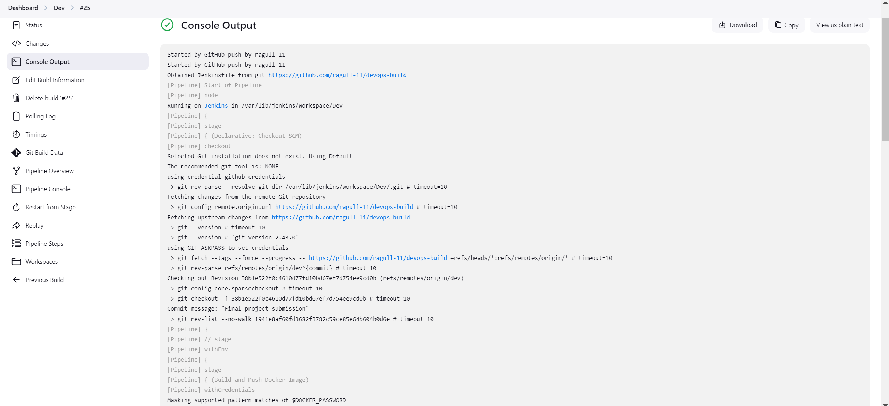  
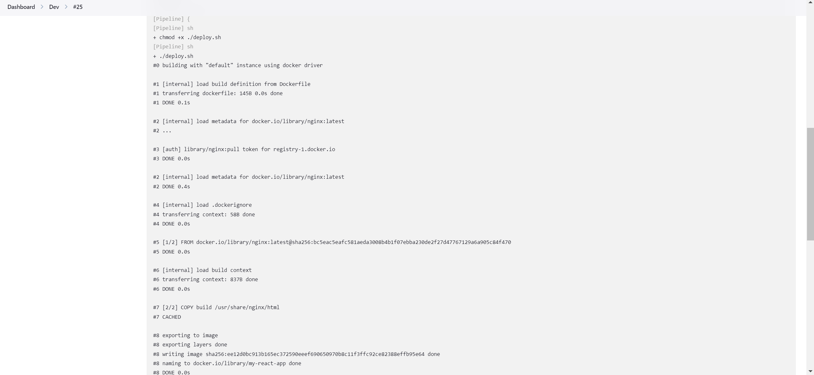  
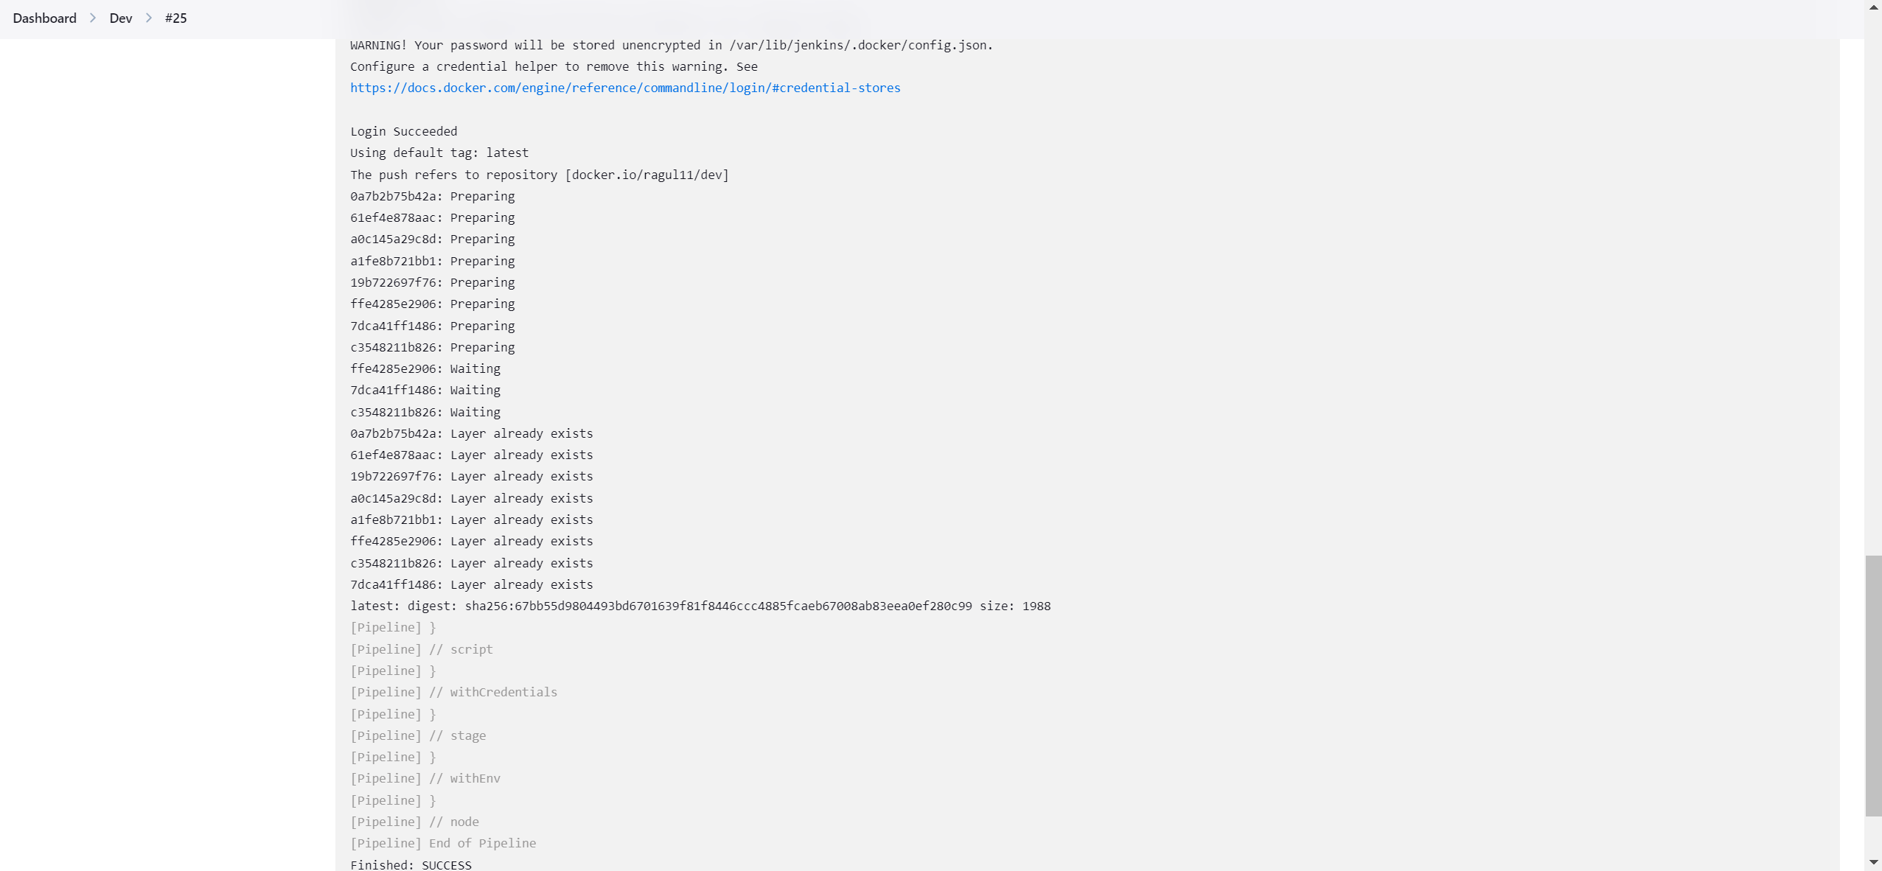**

**AWS  
  
EC2-Instance:**

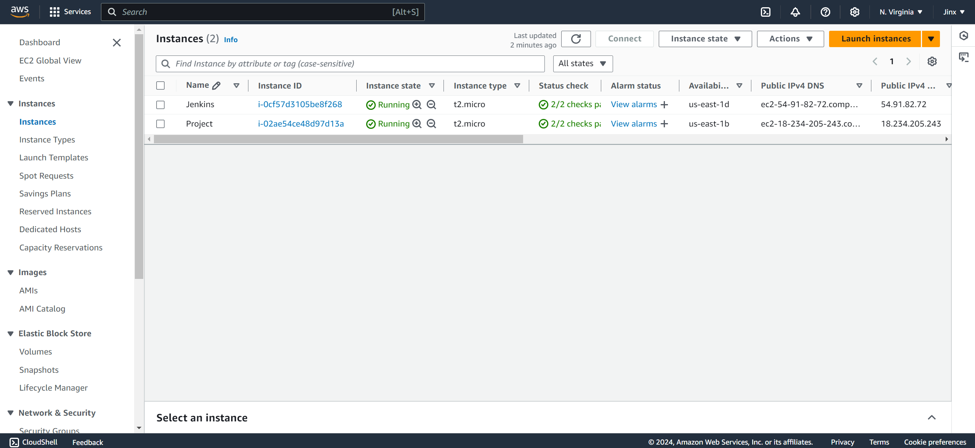

**Security Groups Configs:**

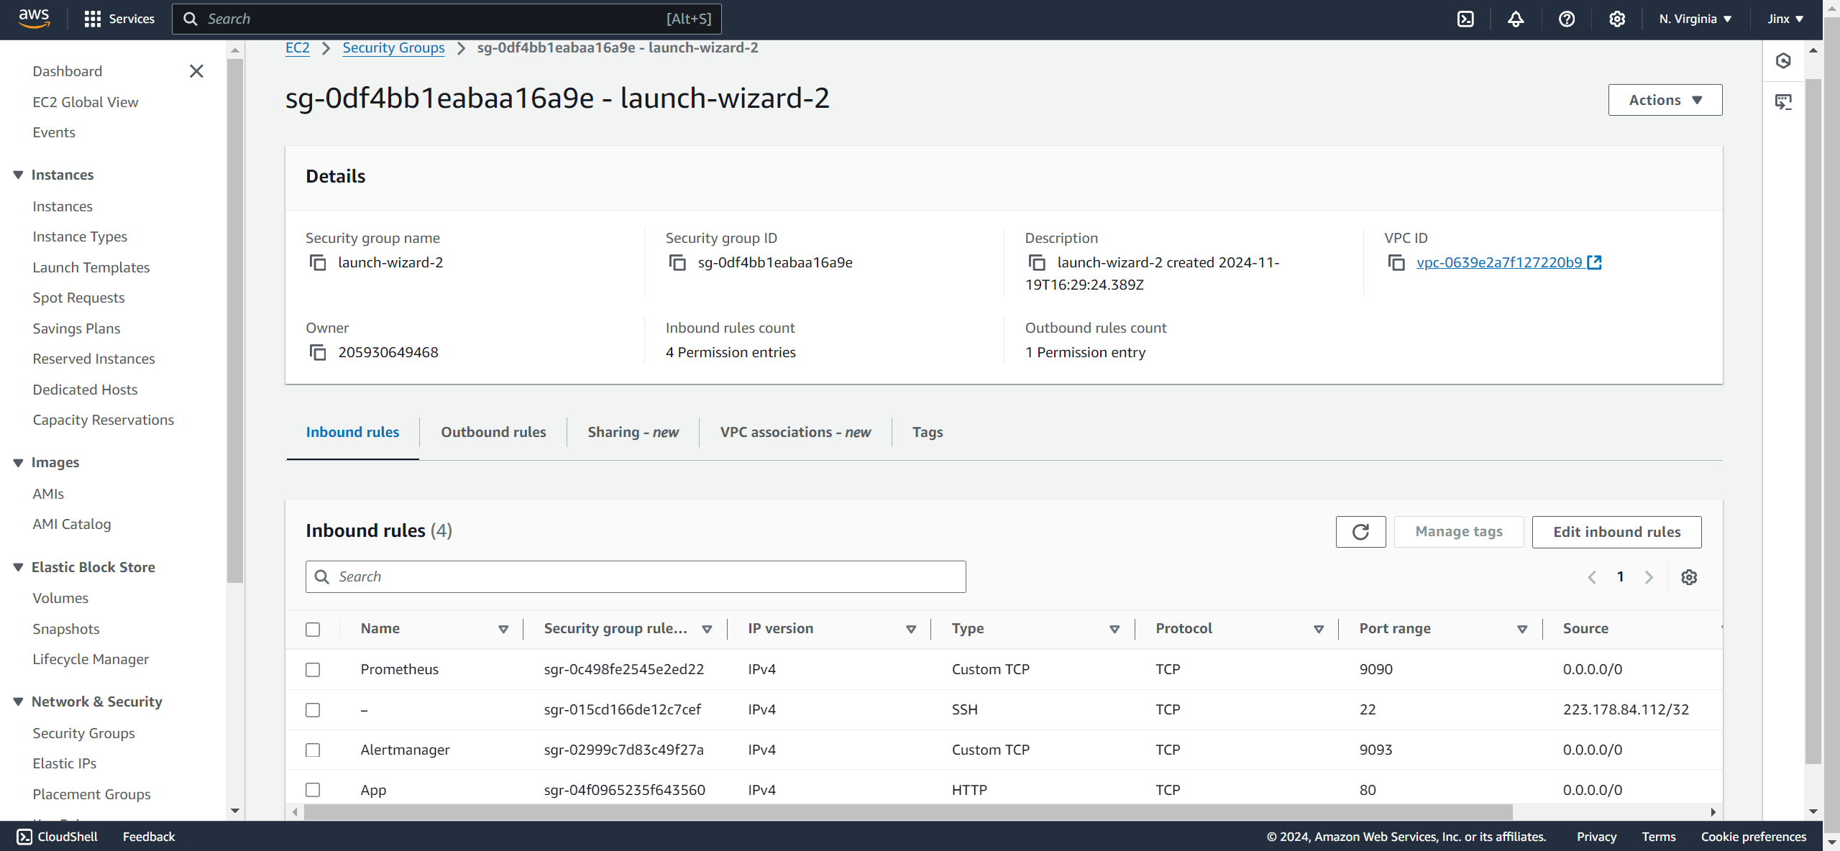

**Monitoring  
  
Prometheus:**

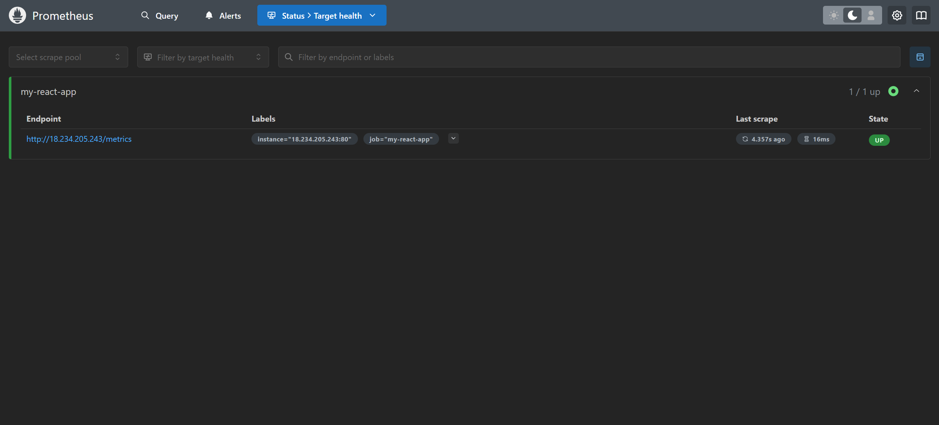

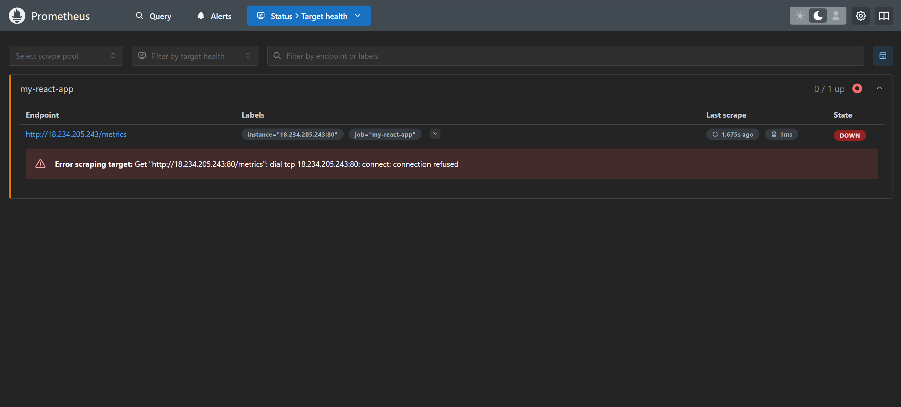

**Grafana Health Check:**

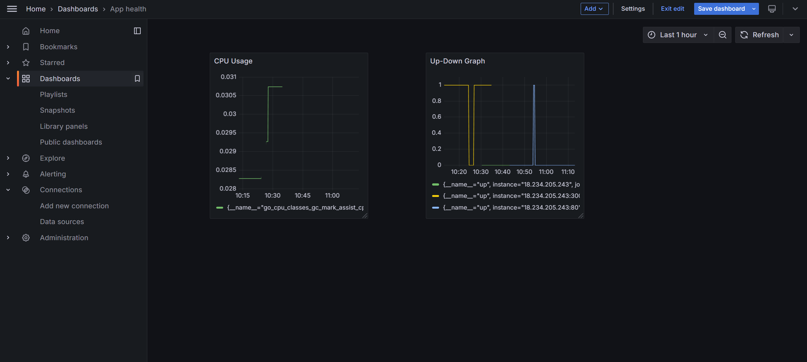

**Alertmanager:**

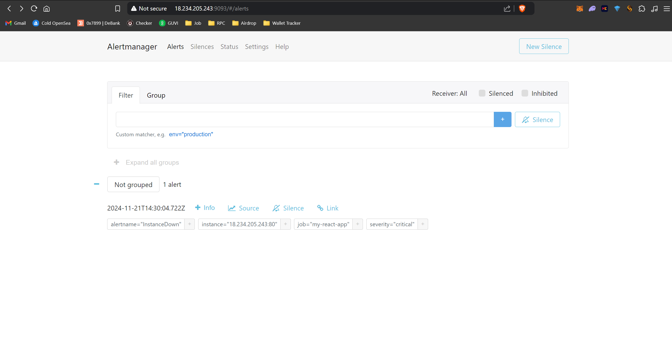

**Alert Notification:**

